Session 6: Grouping and SubqueriesTrainer Coverage:GROUP BY, HAVING.Subqueries and nested queries.Example: “Show users whose average daily spend > ?500.”Pending

Q:-1. Create a SQL query using GROUP BY to show the total number of orders placed by each user in an 'orders' table, displaying user_id and order_count.

select user_id, count(*) as order_count from posts group by user_id;

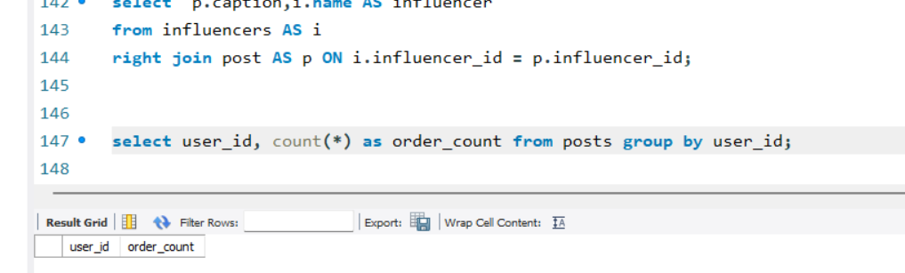

Q:-2 Write a SQL query to display the names of restaurants from a 'restaurants' table that have received an average rating above 4.0, using GROUP BY and HAVING.

select name, avg(rating) AS average_rating from restaurants group by name having avg(rating) > 4.0;

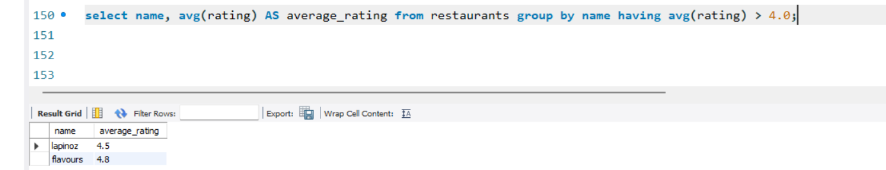

Q:-3. Suppose you have a 'payments' table with columns user_id, amount, and payment_date. Write a subquery to find user_ids who have made a single payment above ₹2000 in any transaction.

select user_id from payments
where user_id in (select user_id from payments where amount > 2000);

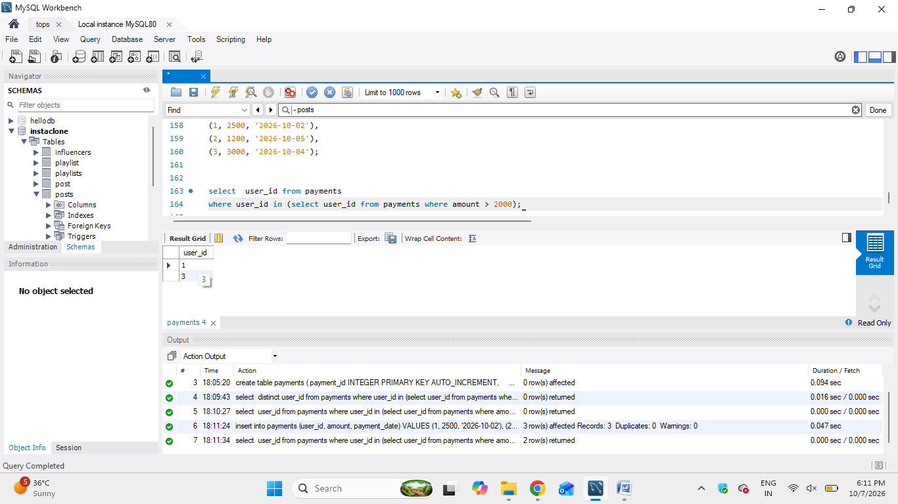
Q:-4. Using a nested subquery, display the names of movies from a 'movies' table that have a higher average rating than the overall average rating of all movies.<br><br><em><strong>Hint:</strong> Use a subquery to calculate the overall average rating, then compare each movie's average rating against it in the main query.</em>

select movie_name, avg(rating) as average_rating
from movies group by movie_name having avg(rating) > (select avg(rating) from movies);

